11. Virtualization
Dual Boot- A dual boot system is a computer system in which two operating systems are installed on the same hard drive, allowing either operating system to be loaded and given control. When you turn the computer on, a boot manager program displays a menu, allowing you to choose the operating system you wish to use.
What is virtualization:
Operating system virtualization refers to the use of software to allow system hardware to run multiple instances of different operating systems concurrently, allowing you to run different applications requiring different operating systems on one computer system.
- able to emulate with the hardware.
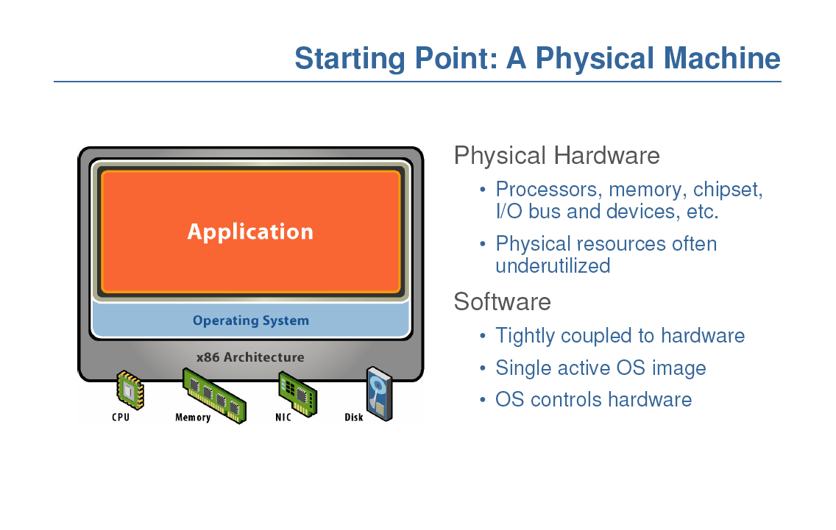
- Purposes - Abstraction, Replication & Isolation
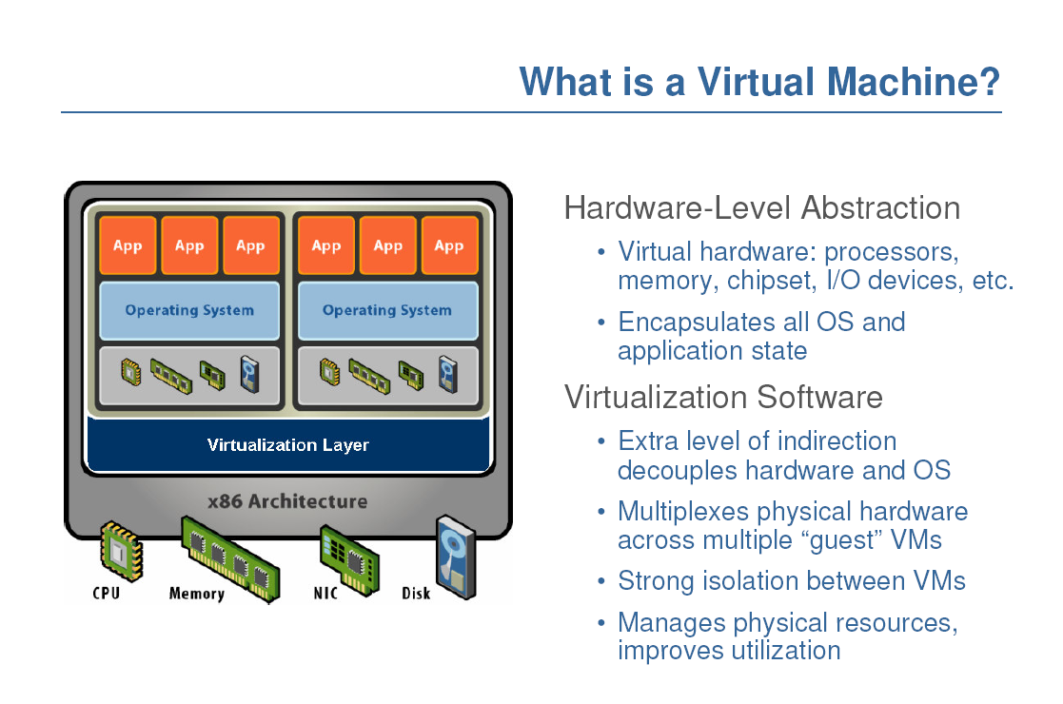
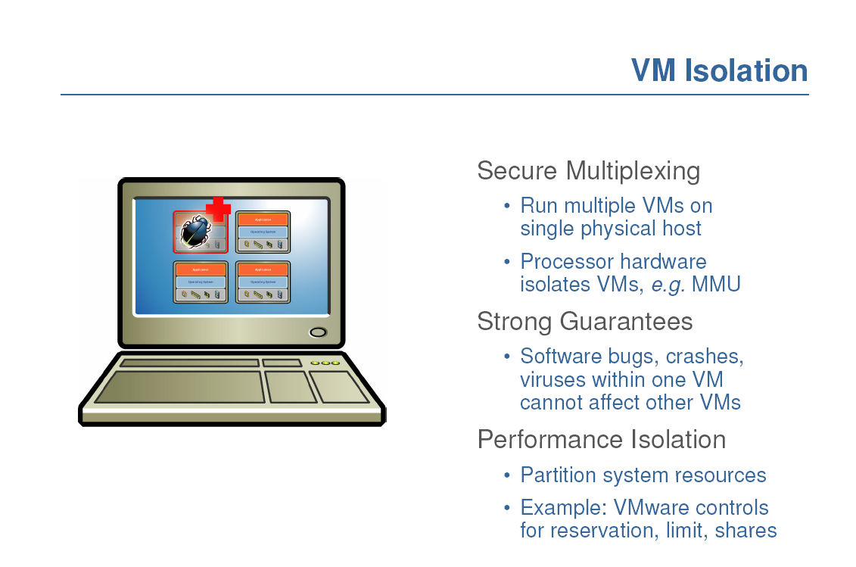
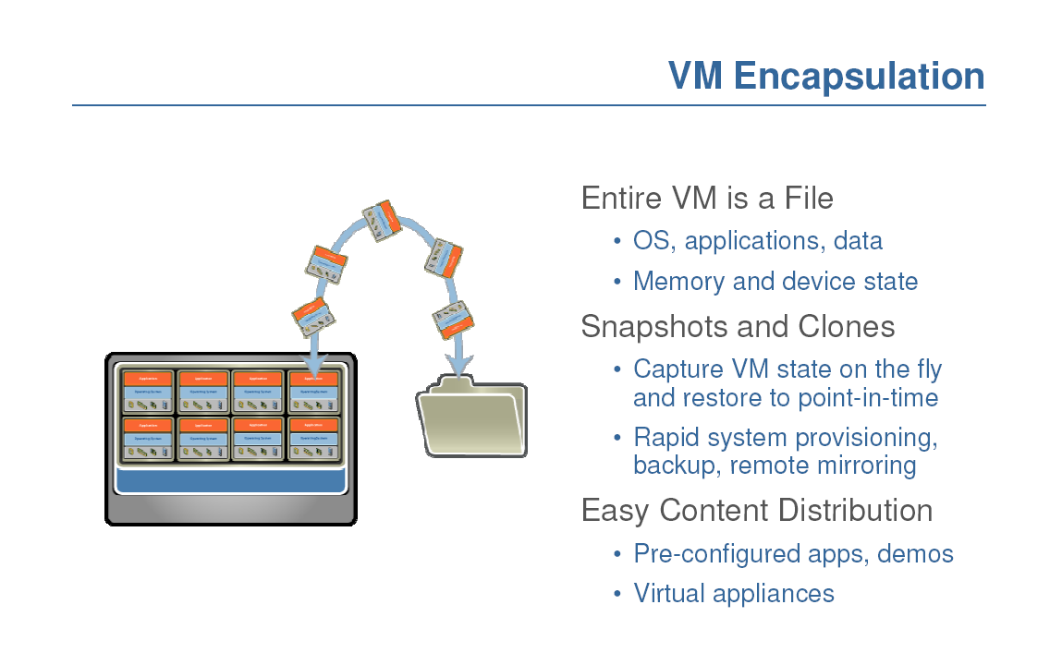
Snapshot - freeze a copy of virtual machine.
Migration - move a VM to another host.
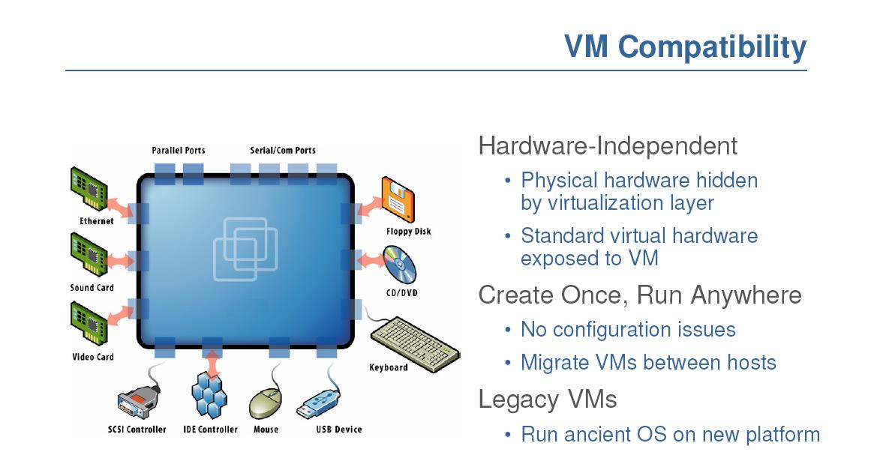
Cloning:
- Simple clone
• Freeze virtual machine
• Copy all files implementing it
• Use copy-on-write to speed up
- Linked clone:
• Take snapshot
• Original and each clone is a copy-on-write version osnapshot
VM workload multiplexing - We expect s3 < s1 + s2
Hypervisor == Virtual Machine
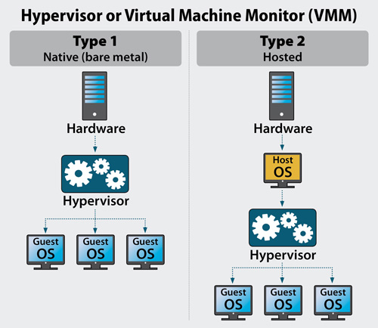
Thee Virtualization Approaches
1. Full Virtualization
2. Paravirtualization
3. Hardware-assisted Virtualization (Allows for type 1)

1- Full virtualization is a virtualization technique used to provide a VME that completely simulates the underlying hardware.

2- Paravirtualization (PV) is an enhancement of virtualization technology in which a guest operating system (guest OS) is modified prior to installation inside a virtual machine (VM) in order to allow all guest OS within the system to share resources and successfully collaborate
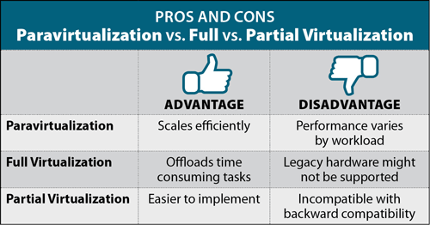
3- Hardware-assisted virtualization is the use of a computer's physical components to support the software that creates and manages virtual machines (Vms).

Hardware-assisted virtualization
• Pros
– It allows to run unmodified OS (so legacy OS can
be run without problems)
• Cons
– Speed and Flexibility
• An unmodified OS does not know it is running
in a virtualized environment and so, it can’t
take advantage of any of the virtualization
features
– It can be resolved using paravirtualization
partially

Page Table A page table is the data structure used by a virtual memory system in a computer operating system to store the mapping between virtual addresses and physical addresses.

